Project Title: Titanic Dataset - Exploratory Data Analysis (EDA)
Dataset: Titanic-Dataset.csv

1. Objective
The objective of this project is to perform Exploratory Data Analysis (EDA) on the Titanic dataset to understand data distribution, identify missing values, analyze feature relationships, and extract meaningful insights that affect passenger survival.

2. Dataset Description
Rows = 891
Columns = 12
The dataset contains passenger information including:
- PassengerId
- Survived (Target Variable)
- Pclass (Ticket Class)
- Name
- Sex
- Age
- SibSp (Siblings/Spouses aboard)
- Parch (Parents/Children aboard)
- Ticket
- Fare
- Cabin
- Embarked

3. Data Preprocessing Steps
- Checked dataset shape and structure using head(), info(), and describe().
- Identified missing values using isnull().sum().
- Observed missing values in Age, Cabin, and Embarked columns.
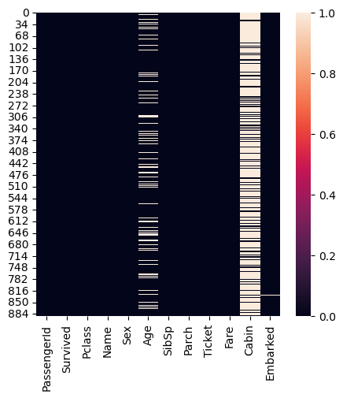
- Basic cleaning and preparation for analysis.

4. Exploratory Data Analysis (EDA)

4.1 Target Variable Analysis (Survived)
Analyzed survival distribution using count plots and percentage calculations. Observed imbalance between survived and non-survived passengers.

4.2 Categorical Feature Analysis
• Sex vs Survival: Female passengers had significantly higher survival rate than males.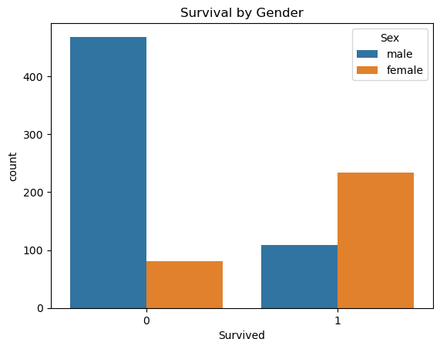

• Pclass vs Survival: 1st class passengers had higher survival compared to 2nd and 3rd class.

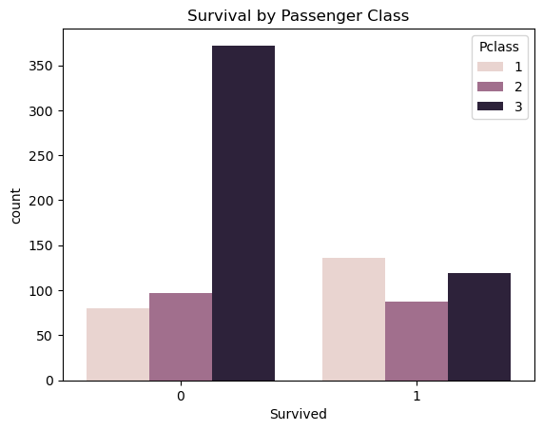

• Embarked vs Survival: Survival rate varied slightly based on embarkation port.

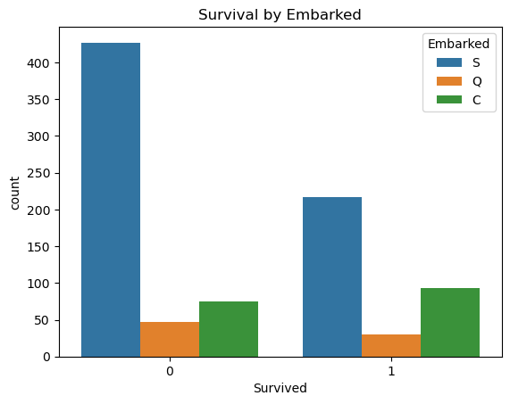

4.3 Numerical Feature Analysis
• Age Distribution: Age showed missing values and varied survival trends.
• Fare Distribution: Fare was right-skewed; higher fare passengers showed better survival chances.
• Boxplots and histograms were used for visualization.

4.4 Correlation Analysis
Generated correlation heatmap for numerical features. Observed moderate relationship between Fare and Pclass. Survival showed relationship with Sex, Pclass, and Fare.

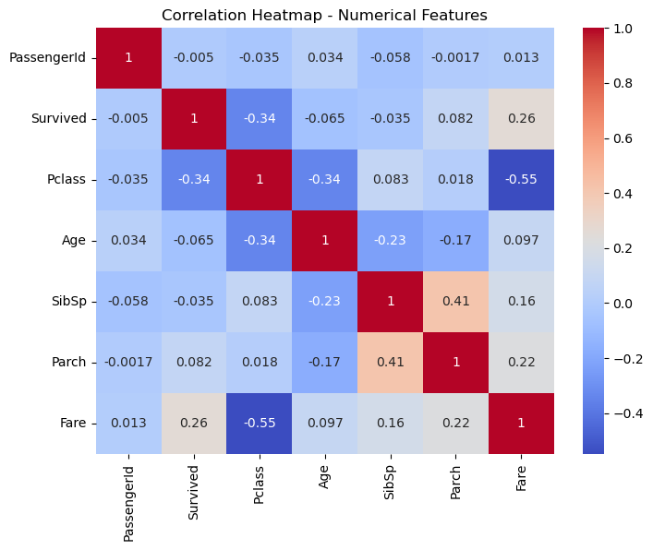

5. Key Insights
1. Female passengers had much higher survival probability.
2. 1st class passengers had better survival chances.
3. Higher fare increased survival chance.
4. Age had missing values and moderate impact on survival.
5. Cabin column contained large number of missing values.

